**UNIX- CASE STUDY**

**Overview of UNIX**

Hardware

O

t

h

e

r

a

p

p

l

i

c

a

t

i

o

n

p

r

o

g

r

a

m

k

e

r

n

a

l

Hardware

UNIX consists of kernel and number of utility programs (command). This utility program acts as a intermediate between a user and a UNIX kernel. The utility program has been written in C language. The kernel is very small and it can reside inside the main memory easily. As shown in the diagram the kernel is in between the hardware and the utility programs. The figure indicates the application program communicate with the kernel through utility program. UNIX OS is easily portable. UNIX kernel is divided into two parts. They are,

* Information management
* Process management

The memory management is linked to process management UNIX is a device independent I/O. A device in the UNIX is treated as a file. Each file for each device is stored inside a /dev. Sometimes there is a generalized device driver in UNIX which can handle any device. So we can say that UNIX as device independent I/O. UNIX file system is based on hierarchies. A process in UNIX will have different priority. If a process with higher priority is need to be executed but there is no memory space. The

UNIX operating system uses two methods. They are,

* Swapping out the whole program • Swapping out only some pages.

This means UNIX follows contiguous, non-contiguous or virtual memory management. The UNIX OS maintains a separate area to store the information regarding a process that area is called as U-area. The process control block is called U-area.

**ARCHITECTURE OF UNIX:**

**INTRODUCTION TO THE KERNEL**

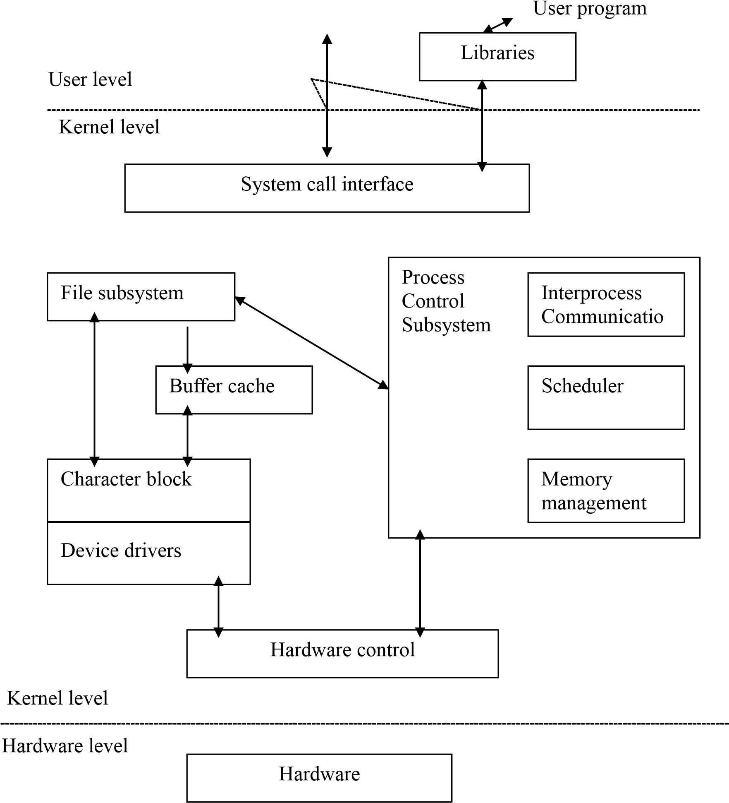

# The Architecture of UNIX has three levels,

User level comprises of user programs which are written using libraries. The hardware level consists of monitors, printer’s management which is controlled by the hardware control and the device drivers. The kernel level mainly consists of information management and the process management. The information management has file subsystem under it. The process management consists of inter process communication, scheduler and memory management.

The file system is used for storing and the maintenance of files. It is the duty of the file system to take the file from the hard disk and write the file to it. The file system also has a connection to hardware control and the process management.

The maintenance of process is done with the help of process management. Two process can communicate using inter process communication. Many process inside the main memory to schedule using a scheduler. The process is stored inside the memory with the help of the memory management. UNIX can follow real memory or virtual memory management system.

**UNIX – FILE SYSTEM:**

Root (/)

A

B

C

A1

C1

C2

A2

B1

C

3

A1

1

A1

2

C1

1

C2

2

C2

1

The UNIX file system is implemented as a hierarchy based file system. It starts with the root directory at the top. The root directory consists of number of directories and these directories in turn consist of subdirectory and files. The above figure, the directory is represented as rectangles and the files are represented as circles. The UNIX a file is a stream of bytes there is no concept called as records example is UNIX kernel using a file system starts to read a file using RBN. The kernel will do the translation of the RBN to LBN is now converted to PBN.

# Commands in UNIX

